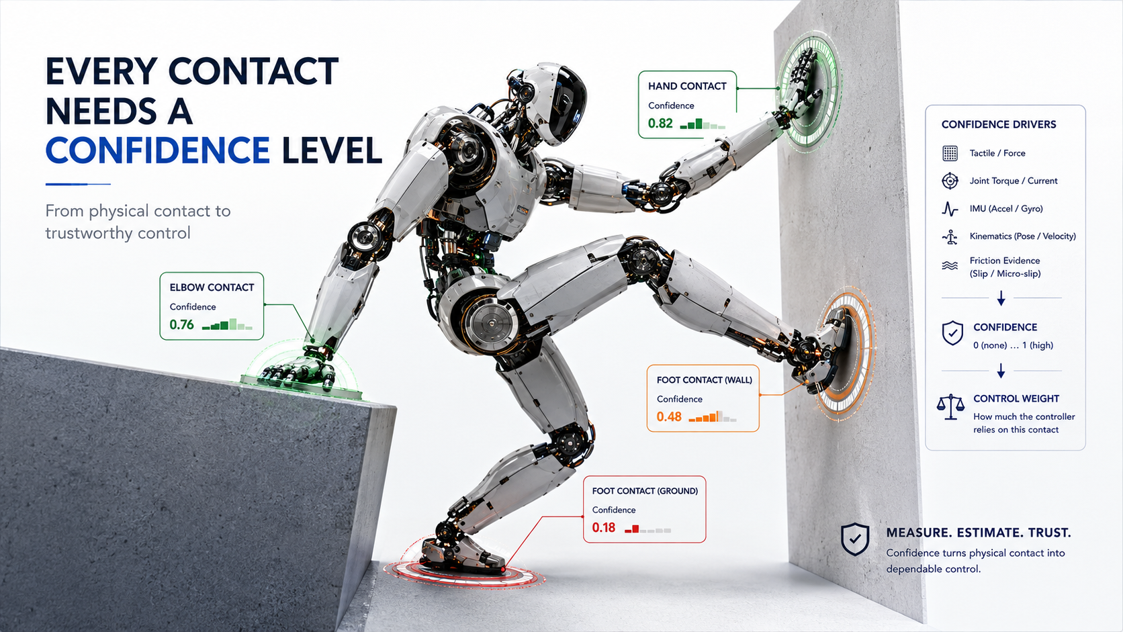

Every Contact Needs a Confidence Level

Contact Reliability, Slip Awareness and the Semiconductor Architecture of Trustworthy Physical Interaction
Author: Dirk Geiger | Date: 2026.09.06 | Contact: info@dxresearch.eu
Reliable humanoid control qualifies every physical contact using synchronized sensor evidence before allocating force, balance authority, or recovery responsibility safely.

A humanoid does not stand on geometry alone. Every step, grasp, push and lean depends on contacts whose friction, stiffness, location and reliability can change within milliseconds. This chapter defines contact confidence as a continuously estimated variable connecting tactile sensing, force estimation, inertial state estimation and whole-body control. Recent research shows that humanoids can infer external forces without dedicated force sensors, reconstruct frictional contact forces from dynamics, and use dense tactile skin for real-time multicontact interaction. The control implication is significant: a planned support should not be treated as binary contact simply because kinematics predict it. The robot should estimate whether each contact is present, stable, slipping, saturated or uncertain, then adapt force distribution and motion accordingly. Semiconductor architecture enables this through synchronized current, position, inertial, force and tactile acquisition, deterministic communication and real-time estimation. Physical AI becomes more robust when every contact carries both a force estimate and confidence.

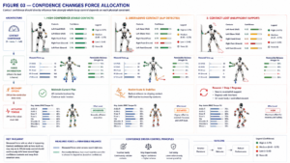
A contact is not binary. Credit: DXresearch.eu.

A Contact Is Not Binary
A planned support can be geometrically present while mechanically unreliable.
Contact state
should distinguish touching, loaded, stable, slipping and lost conditions. Humanoid research shows that external interaction can be estimated even on body parts without dedicated force sensors and used by multicontact control. [1]

Confidence Is the Missing Control Variable
The useful question is not merely whether contact exists, but how strongly control should rely on it.
Contact confidence
turns heterogeneous evidence into a bounded statement about support reliability. High confidence permits stronger force allocation. Falling confidence should progressively reduce reliance before the contact disappears.

Force and Friction Must Be Estimated
A
contact wrench
describes forces and moments transmitted through support. PRIME demonstrates physically consistent reconstruction of frictional contact forces from robot dynamics. [2] The remaining
friction margin
determines how much tangential demand can be added before slip.

Slip Starts Before Contact Is Lost
Incipient slip
provides warning before gross sliding. Tactile research shows local contact patterns can reveal this transition. [4] Dense data protocols improve learned tactile slip detection across contact conditions. [5]

The Whole Body Creates Redundancy
In
multicontact
behavior, feet, hands, forearms or other surfaces can share support. Whole-body tactile interaction research demonstrates real-time extraction of contact information and its use in humanoid control. [3] If one contact degrades, force can migrate toward contacts with better evidence and margin.

Confidence Depends on Observability
A contact may be real but poorly observable.
Contact observability
depends on sensor placement, model quality, excitation and timing. Motor current can suggest external torque; joint position reveals kinematic consistency; IMUs reveal body response; tactile arrays provide local evidence.

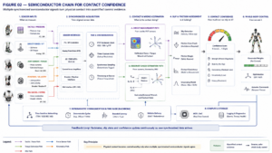
Synchronized sensing turns interaction into quantified contact evidence. Credit: DXresearch.eu.

The Semiconductor Control Chain
Contact confidence begins in synchronized acquisition. Tactile and force interfaces, motor-current sensing, position feedback and inertial sensors must describe approximately the same physical event. Deterministic communication and timestamps preserve temporal relationships. Real-time estimation converts evidence into contact state, wrench, slip risk and confidence before whole-body control allocates torque.

Saturation Is Different from Failure
A contact can remain present while reaching
contact saturation
. Required tangential force may approach friction limits, or normal force may approach structural limits. Confidence should therefore represent usable authority, not merely detection probability.

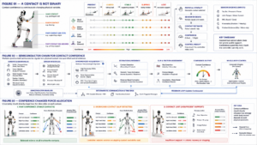
Force migrates toward trustworthy contacts as confidence degrades. Credit: DXresearch.eu.

Control Should Degrade Reliance Smoothly
Binary contact logic creates abrupt transitions. Confidence-weighted control can progressively shift force, shorten steps, slow manipulation, add hand support or initiate recovery. When confidence falls below validated limits, the robot must select another physical strategy.

Conclusion
Physical AI acts through contacts, and every contact is uncertain. Robust humanoids need a control abstraction joining tactile evidence, force estimation, dynamics, friction and timing into a continuously updated statement of trust. Contact confidence makes that statement actionable.

References
- IEEE AMC. Estimation-based Control of Forces Applied to Parts of Humanoids That Do Not Have Force Sensors. 2026. https://ieeexplore.ieee.org/
- Kang et al.. PRIME: Physically-consistent Robotic Inertial and Motion Estimation for Legged and Humanoid Robots. 2026. https://arxiv.org/
- Armleder et al.. Real-Time Control of a Humanoid Robot for Whole-Body Tactile Interaction. 2025. https://arxiv.org/
- Zhao et al.. Universal slip detection of robotic hand with tactile sensing. 2025. https://doi.org/
- Zenha et al.. Let’s DENSE: a novel protocol for efficiently collecting dense and diverse data for tactile slip detection in robotic grasping. 2025. https://arxiv.org/

Glossary
Contact confidence: Estimated reliability that a physical contact can support the force assumed by control.
Contact observability: Degree to which available measurements allow contact state and force to be inferred.
Contact saturation: Condition where required contact force approaches the feasible contact limit.
Contact state: Classification of whether and how a robot is physically interacting with its environment.
Contact wrench: Forces and moments acting through a physical contact.
Friction margin: Remaining tangential-force capability before a contact begins to slip.
Incipient slip: Transition toward relative motion before gross sliding occurs.
Multicontact: Simultaneous physical support or interaction through multiple body regions.

Sources
Estimation-based Control of Forces Applied to Parts of Humanoids That Do Not Have Force Sensors · 2026 · IEEE AMC · https://ieeexplore.ieee.org/
Let’s DENSE: a novel protocol for efficiently collecting dense and diverse data for tactile slip detection in robotic grasping · 2025 · Zenha et al. · https://arxiv.org/
PRIME: Physically-consistent Robotic Inertial and Motion Estimation for Legged and Humanoid Robots · 2026 · Kang et al. · https://arxiv.org/
Real-Time Control of a Humanoid Robot for Whole-Body Tactile Interaction · 2025 · Advanced Intelligent Systems · https://doi.org/10.1002/aisy.202500149
Universal slip detection of robotic hand with tactile sensing · 2025 · Zhao et al. · https://doi.org/

