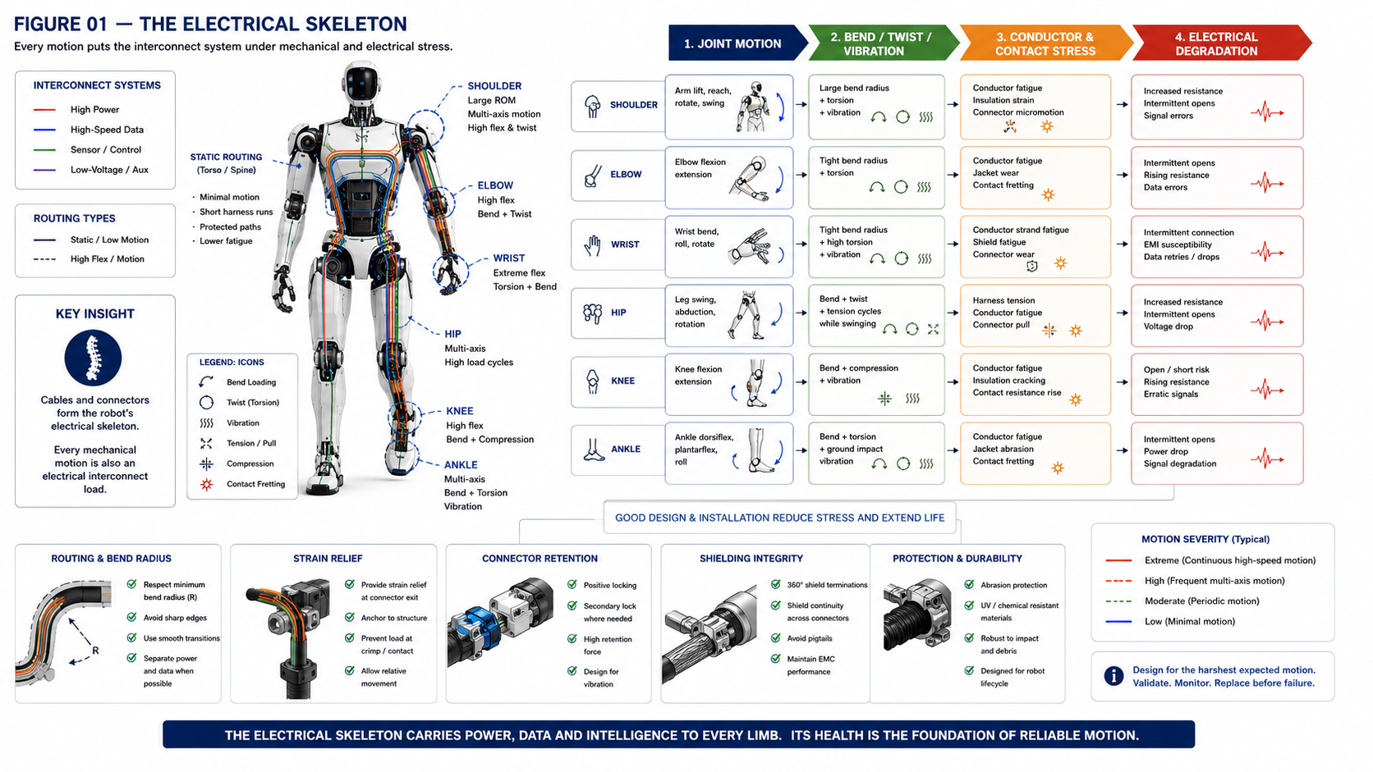

The Robot Has an Electrical Skeleton

Designing Cables, Connectors and Interconnect Diagnostics for a Body That Never Stops Moving
Author: Dirk Geiger | Date: 2026.09.06 | Contact: info@dxresearch.eu
Humanoid cables and connectors must remain trustworthy through repeated bending, twisting, vibration and wear across millions of demanding body movements.

Humanoid electronics depend on an overlooked mechanical system: the cables and connectors carrying power, sensing and communication through continuously moving joints. Every step, reach and wrist rotation bends, twists or vibrates conductors, shields and contacts. Recent 2026 research identifies dynamic bending, compact routing and simultaneous power-signal transmission as defining humanoid cable requirements, while connector suppliers highlight flex life, retention, shielding and strain relief as critical design constraints. This chapter treats the interconnect network as the robot’s electrical skeleton: a distributed structure that must survive motion while preserving voltage, signal integrity and diagnostic visibility. The architecture combines high-flex conductors, controlled routing, robust connectors, shielding, local power distribution, Ethernet link diagnostics and lifecycle monitoring. Semiconductor intelligence can expose rising resistance, degraded signal quality, intermittent links and cable faults before motion becomes unsafe. A scalable humanoid should know whether its electrical pathways remain trustworthy while its mechanical body accumulates millions of motion cycles.

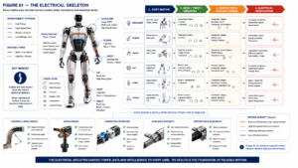
Every mechanical motion is also an electrical interconnect load.

The Hidden Mechanical System
Dynamic flex life
Bend radius
Torsional loading
Contact resistance
Shield continuity
Signal quality indicator
Time-domain reflectometry
Interconnect health
. Humanoid cables face dynamic bending and compact routing constraints. [1]

Motion Accumulates Electrical Risk
Harness strain histories can support fatigue-life prediction. [2] [3]

Connectors Move Too
Retention, shielding and strain relief are humanoid interconnect constraints. [4] [7]

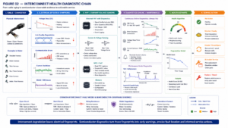
Electrical evidence can expose degradation before failure.

The Semiconductor Diagnostic Chain
Ethernet PHY diagnostics can expose link quality and cable faults through mechanisms including SQI and TDR. [6]

Condition Monitoring
Moving robotic cable systems already use condition monitoring. [5] Combining motion exposure with electrical diagnostics enables health estimation.

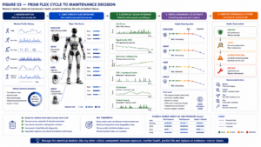
Service can follow measured exposure and electrical health.

Conclusion
A scalable humanoid should know whether its moving electrical pathways remain trustworthy and service them before intermittent degradation becomes functional failure.

References
- Wire & Cable. Research Status of Humanoid Robot Cables. 2026. https://doi.org/10.16105/j.dxdl.1672-6901.20260069
- Journal of Mechanical Science and Technology. Fatigue life prediction of a cable harness in an industrial robot using dynamic simulation. 2008. https://link.springer.com/
- Key Engineering Materials. The Simulation and Fatigue Life Prediction of a Cable Harness in an Industrial Robot. 2011. https://www.scientific.net/
- Molex. Humanoid Robotics Connectors and Interconnect Solutions. tbd. https://www.molex.com/
- igus. i.Sense TR.B condition monitoring for triflex R 3D chains. tbd. https://www.igus.com/
- Texas Instruments. Using Single-Pair Ethernet in Humanoid Robots. tbd. https://www.ti.com/
- Amphenol Communications Solutions. Technologies Driving Reliable Connections in Humanoid Robots. tbd. https://www.amphenol-cs.com/

Glossary
Bend radius: Bend radius is a key interconnect lifecycle and diagnostic concept for moving robotic electrical systems.
Contact resistance: Contact resistance is a key interconnect lifecycle and diagnostic concept for moving robotic electrical systems.
Dynamic flex life: Dynamic flex life is a key interconnect lifecycle and diagnostic concept for moving robotic electrical systems.
Interconnect health: Interconnect health is a key interconnect lifecycle and diagnostic concept for moving robotic electrical systems.
Shield continuity: Shield continuity is a key interconnect lifecycle and diagnostic concept for moving robotic electrical systems.
Signal quality indicator: Signal quality indicator is a key interconnect lifecycle and diagnostic concept for moving robotic electrical systems.
Time-domain reflectometry: Time-domain reflectometry is a key interconnect lifecycle and diagnostic concept for moving robotic electrical systems.
Torsional loading: Torsional loading is a key interconnect lifecycle and diagnostic concept for moving robotic electrical systems.

Sources
Fatigue life prediction of a cable harness in an industrial robot using dynamic simulation · 2008 · Journal of Mechanical Science and Technology · https://link.springer.com/
Humanoid Robotics Connectors and Interconnect Solutions · tbd · Molex · https://www.molex.com/
i.Sense TR.B condition monitoring for triflex R 3D chains · tbd · igus · https://www.igus.com/
Research Status of Humanoid Robot Cables · 2026 · Wire & Cable · https://doi.org/10.16105/j.dxdl.1672-6901.20260069
Technologies Driving Reliable Connections in Humanoid Robots · tbd · Amphenol Communications Solutions · https://www.amphenol-cs.com/
The Simulation and Fatigue Life Prediction of a Cable Harness in an Industrial Robot · 2011 · Key Engineering Materials · https://www.scientific.net/
Using Single-Pair Ethernet in Humanoid Robots · tbd · Texas Instruments · https://www.ti.com/

