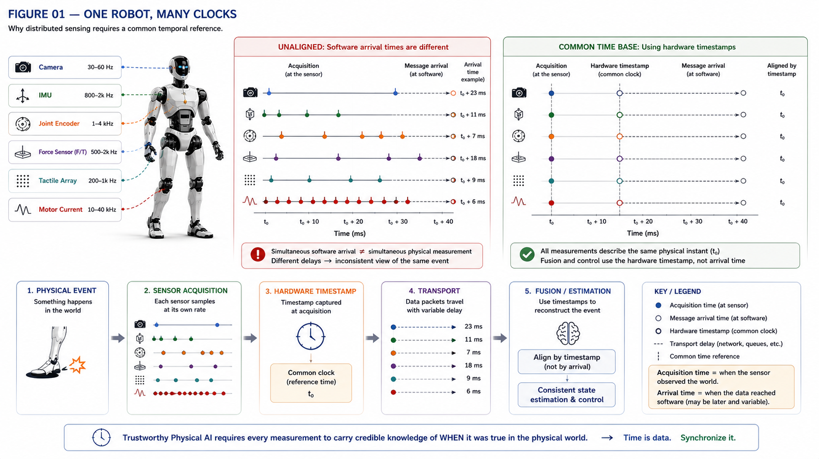

The Robot Needs a Common Clock

Time Synchronization, Hardware Timestamping and Temporal Integrity Across the Humanoid Body
Author: Dirk Geiger | Date: 2026.09.06 | Contact: info@dxresearch.eu
Humanoid control needs synchronized timestamps so distributed sensors, actuators, estimators and safety logic describe the same physical moment reliably together.

A humanoid cannot fuse what happened at different moments as though it happened simultaneously. Cameras, IMUs, joint encoders, force sensors, motor currents and tactile arrays operate at different rates, with independent clocks, transport delays and jitter. This chapter treats time as a first-class robot state. Accurate timestamps and bounded clock error let perception reconstruct motion, state estimators align measurements, controllers associate torque with position, and safety logic distinguish stale data from current evidence. Modern robotics platforms already use hardware timestamping, PTP and synchronized triggers to correlate distributed sensors, while simulation frameworks publish a common clock so virtual nodes share one temporal reference. The semiconductor implication spans oscillators, timers, Ethernet timestamping, sensor interfaces, deterministic networks, MCUs and diagnostics for clock health. A scalable humanoid needs temporal integrity across the body: every measurement should carry not only a value, but credible knowledge of when that value became true in the physical world.

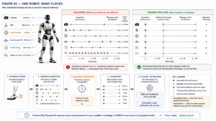
Simultaneous software arrival does not mean simultaneous physical measurement.

Time Is Part of Every Measurement
Temporal integrity
Acquisition timestamp
Clock offset
Clock drift
Jitter
PTP
Distributed clock
Propagation-delay compensation
Stale data
. A sensor value without credible timing can be numerically accurate yet physically misleading. The key distinction is between acquisition time and later software arrival.

One Robot, Many Clocks
Cameras, IMUs, encoders and motor-control nodes run at different rates and may own independent oscillators. IEEE 1588 defines precision clock synchronization for distributed measurement and control systems. [1] Its amendment continues that standards framework. [2]

Hardware Timestamping Moves Time Closer to Physics
Timestamping near sensor acquisition reduces uncertainty introduced by interrupts, queues and operating-system scheduling. NVIDIA robotics platforms document synchronized sensor acquisition and correlated timestamp mechanisms. [4] [5]

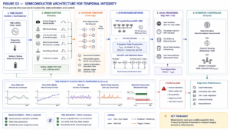
Temporal integrity spans oscillators, capture units, synchronized networks and real-time compute.

Networks Must Carry Time as Well as Data
EtherCAT Distributed Clocks provide synchronized local hardware clocks and compensate communication propagation delay. [3] PTP hardware-clock infrastructure similarly exposes hardware timing capabilities to software. [8]

Controllers Need Data Age, Not Only Data Values
State estimation should reason about measurement age, clock error and transport uncertainty. Old evidence can be classified as stale rather than silently fused into a current state. This matters when fast body motion turns milliseconds of timing error into position, velocity or force inconsistency.

Simulation Needs the Same Temporal Contract
ROS 2 explicitly abstracts time for robotic systems. [6] Isaac Sim can publish simulation time so distributed ROS nodes operate against a shared virtual clock. [7] That temporal contract helps software preserve event ordering and sensor-age assumptions across simulation and hardware.

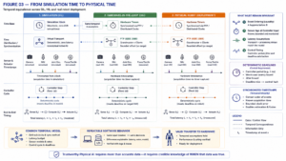
A common temporal model improves transfer from simulation through HIL to the physical robot.

Conclusion
A scalable humanoid needs temporal integrity across its body. Every critical measurement should answer two questions: what was observed, and when was it physically true? Synchronization, timestamps and clock-health diagnostics make distributed evidence coherent enough for perception, control and safety.

References
- IEEE. IEEE 1588-2019 Standard for a Precision Clock Synchronization Protocol for Networked Measurement and Control Systems. 2019. https://standards.ieee.org/standard/1588-2019.html
- IEEE. IEEE 1588a-2023 Amendment. 2023. https://standards.ieee.org/
- EtherCAT Technology Group. Distributed Clocks for High-Precision Synchronization. tbd. https://www.ethercat.org/
- NVIDIA. Nova Orin Developer Kit Documentation. tbd. https://nvidia-isaac-ros.github.io/
- NVIDIA. Isaac ROS Correlated Timestamp Driver. tbd. https://nvidia-isaac-ros.github.io/
- ROS 2 Design. Clock and Time. tbd. https://design.ros2.org/articles/clock_and_time.html
- NVIDIA Isaac Sim. ROS 2 Reference Architecture / Simulation Time. tbd. https://docs.isaacsim.omniverse.nvidia.com/
- Linux Kernel Documentation. PTP Hardware Clock Infrastructure. tbd. https://docs.kernel.org/driver-api/ptp.html

Glossary
Acquisition timestamp: Time at which a physical quantity was sampled rather than received by software.
Clock drift: Change in clock offset over time.
Clock offset: Instantaneous difference between two clocks.
Distributed clock: Synchronized local hardware clock maintained across networked nodes.
Jitter: Variation in timing around an intended event.
Propagation-delay compensation: Correction for time consumed transporting synchronization information.
PTP: IEEE 1588 Precision Time Protocol for synchronizing clocks in distributed systems.
Stale data: Information whose age exceeds its valid control or estimation window.
Temporal integrity: Confidence that measurements and actions are correctly associated with physical time.

Sources
Clock and Time · tbd · ROS 2 Design · https://design.ros2.org/articles/clock_and_time.html
Distributed Clocks for High-Precision Synchronization · tbd · EtherCAT Technology Group · https://www.ethercat.org/
IEEE 1588-2019 Standard for a Precision Clock Synchronization Protocol for Networked Measurement and Control Systems · 2019 · IEEE · https://standards.ieee.org/standard/1588-2019.html
IEEE 1588a-2023 Amendment · 2023 · IEEE · https://standards.ieee.org/
Isaac ROS Correlated Timestamp Driver · tbd · NVIDIA · https://nvidia-isaac-ros.github.io/
Nova Orin Developer Kit Documentation · tbd · NVIDIA · https://nvidia-isaac-ros.github.io/
PTP Hardware Clock Infrastructure · tbd · Linux Kernel Documentation · https://docs.kernel.org/driver-api/ptp.html
ROS 2 Reference Architecture / Simulation Time · tbd · NVIDIA Isaac Sim · https://docs.isaacsim.omniverse.nvidia.com/

