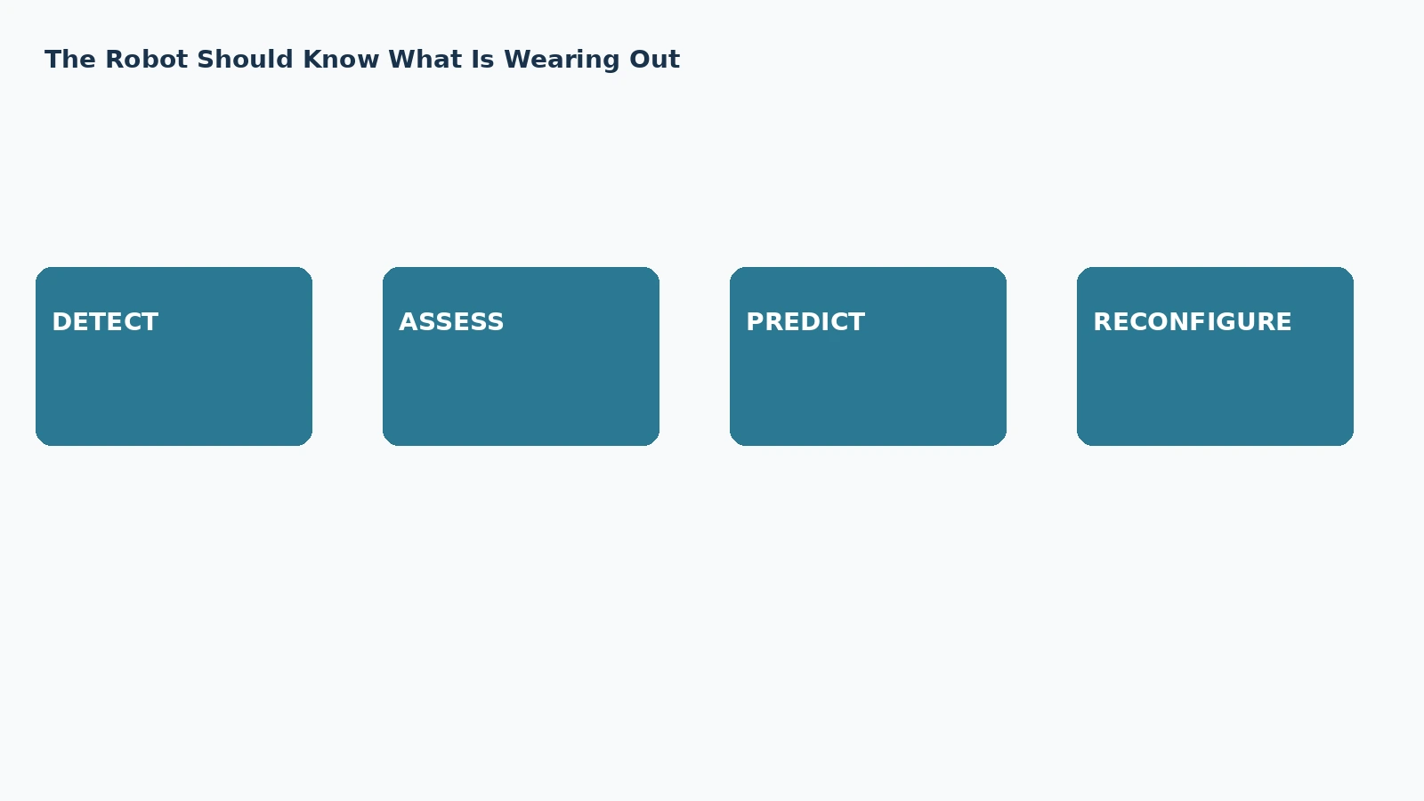

The Robot Should Know What Is Wearing Out

Health-Aware Motion, Degradation Estimation and Graceful Loss of Capability
Author: Dirk Geiger | Date: 2026.09.06 | Contact: info@dxresearch.eu
Health-aware humanoids estimate component degradation, redistribute mechanical load, and deliberately reduce capability before weakened joints or sensors become dangerous failures.

A humanoid built for work cannot treat every joint as equally healthy forever. Bearings wear, reducers develop backlash, sensors drift, motors lose margin, cables loosen and actuators may partially fail. This chapter defines health-aware motion as the control layer that converts component condition into robot behavior. Rather than waiting for a fault threshold and stopping, the robot estimates degradation, remaining useful life and available actuator authority, then redistributes motion and load across redundant degrees of freedom. Recent research demonstrates remaining-life-aware trajectory planning, fault reconstruction, fault-tolerant control and motion reconfiguration after joint failure. The semiconductor implication connects current, position, temperature and vibration sensing with diagnostics, real-time control, nonvolatile health history and safe reconfiguration. The objective is not to hide faults or extend operation recklessly. It is to preserve useful capability inside verified limits, reduce stress on weak components, and transition from normal operation to degraded operation, maintenance or a minimum-risk state.

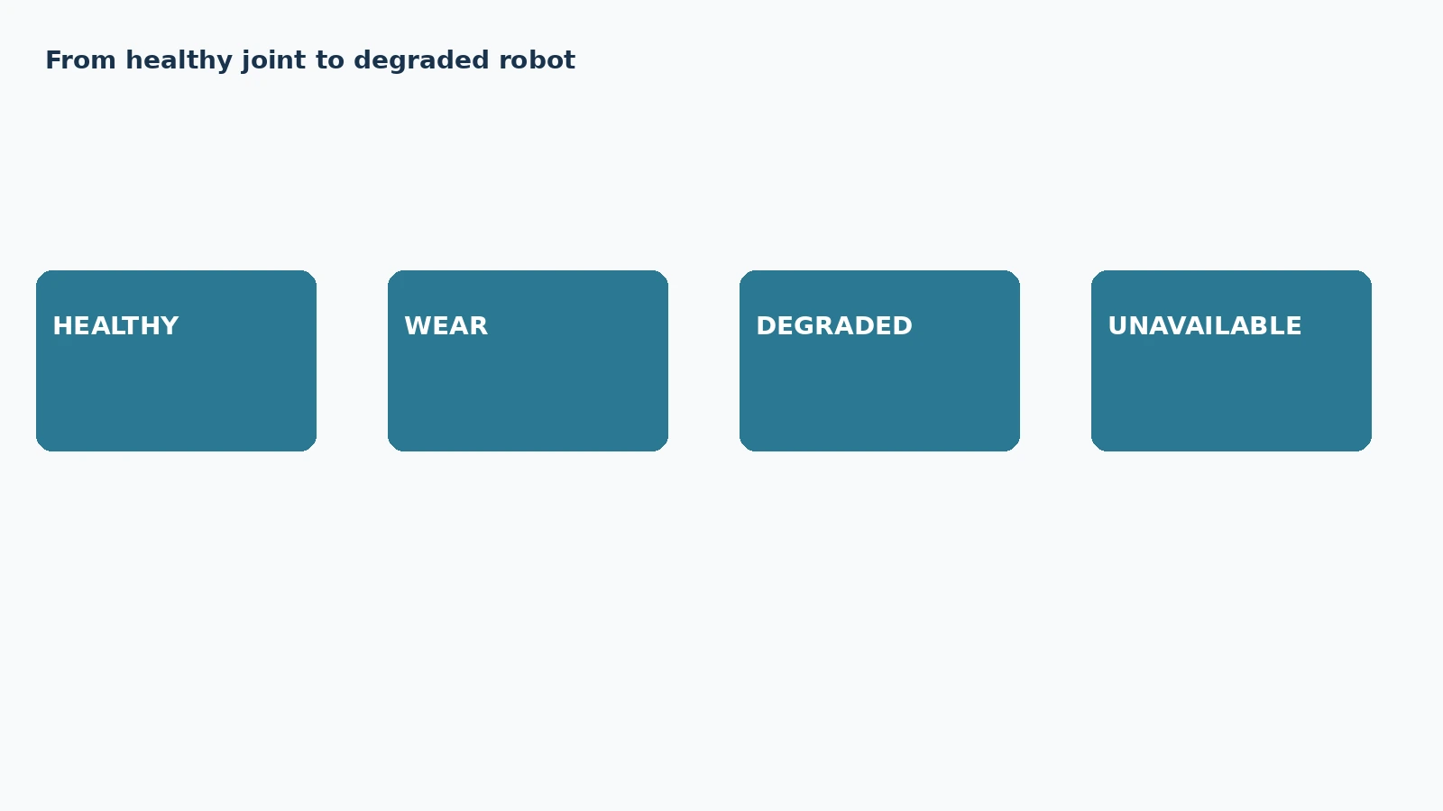
Capability should change before degradation becomes hard failure.

Health Is a Control Input
Component health
Degradation
Remaining useful life
Available actuator authority
Fault reconstruction
Fault accommodation
Graceful degradation
Health-aware motion planning
. A working robot accumulates evidence about its condition. That evidence should change permissible motion, not remain isolated in maintenance logs.

Predict Before Failure
Remaining-life-aware planning can balance degradation across actuators instead of repeatedly consuming the weakest joint. [1] Fault reconstruction provides richer evidence than binary diagnostics. [2]

Authority Can Decrease Gradually
Fault-tolerant control under actuator saturation shows why available power and torque must become explicit control constraints. [3] Humanoid joint reconfiguration demonstrates that redundant joints can preserve selected motions after failure. [4]

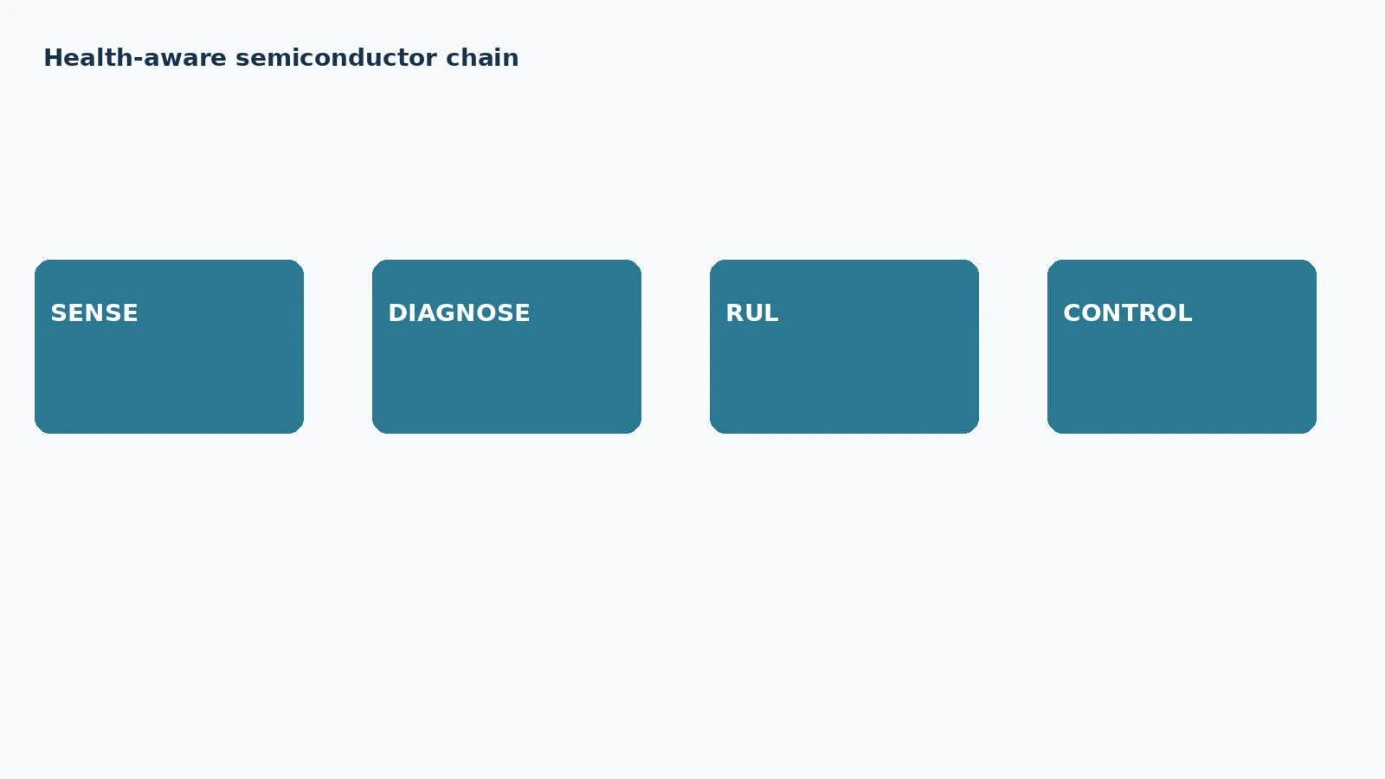
Semiconductor telemetry becomes useful when health changes permissible behavior.

The Semiconductor Chain
Current, position, temperature and vibration sensing feed synchronized diagnostics and health estimation. Industrial robot degradation research combines dynamics, servo information and motor-current features for condition assessment. [5] Reliability research models coupled wear, fatigue and shock processes. [6]

Graceful Degradation
Safe reconfiguration means progressively reducing load, speed, payload or task scope inside verified limits. It does not mean hiding a fault or operating indefinitely with damaged hardware.

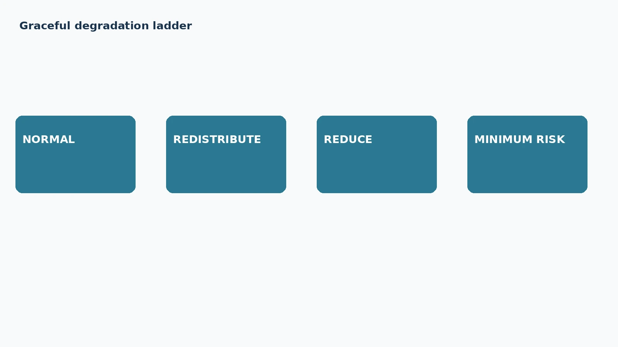
Graceful degradation deliberately moves from normal operation toward maintenance or minimum risk.

Conclusion
A mature humanoid should know not only what it can do, but what its components can still do reliably. Health-aware motion connects physical degradation to whole-body behavior and turns redundancy into a reliability resource.

References
- Li & Zeng / PHM Europe. RUL-Aware RRT: Degradation-Balanced Motion Planning for Robotic Manipulators. 2026-07-03. https://papers.phmsociety.org/
- Control Engineering Practice. Sliding mode-based actuator fault reconstruction and fault-tolerant control of lower limb rehabilitation exoskeleton robots. 2026-02. https://www.sciencedirect.com/
- ISA Transactions. Fault tolerant adaptive control under actuator saturation for robot manipulators. 2026-01. https://www.sciencedirect.com/
- Robotics research. Joint Reconfiguration after Failure for Performing Emblematic Gestures in Humanoid Receptionist Robot. tbd. https://scholar.google.com/
- Wang et al.. A degradation assessment method for industrial robot in flexible manufacturing systems based on multiple physics-informed neural network. tbd. https://www.sciencedirect.com/
- Ling et al.. Reliability Modeling of Systems under Dependent Competing Failures Using Bilateral Coupling Variables. 2026. https://www.mdpi.com/

Glossary
Available actuator authority: Torque, speed or control capability currently considered dependable.
Component health: Estimated condition of an actuator, sensor, transmission or subsystem relative to expected functional capability.
Degradation: Progressive loss of performance or margin before functional failure.
Fault accommodation: Modification of control to operate within changed component capability.
Fault reconstruction: Estimation of fault magnitude or behavior rather than binary detection alone.
Graceful degradation: Controlled reduction of capability while preserving verified safety and as much useful operation as remains trustworthy.
Health-aware motion planning: Trajectory generation incorporating component condition or predicted degradation into costs and constraints.
Remaining useful life: Estimated usable operating duration before a defined failure criterion.

Sources
A degradation assessment method for industrial robot in flexible manufacturing systems based on multiple physics-informed neural network · tbd · Wang et al. · https://www.sciencedirect.com/
Fault tolerant adaptive control under actuator saturation for robot manipulators · 2026-01 · ISA Transactions · https://www.sciencedirect.com/
Joint Reconfiguration after Failure for Performing Emblematic Gestures in Humanoid Receptionist Robot · tbd · Robotics research · https://scholar.google.com/
Reliability Modeling of Systems under Dependent Competing Failures Using Bilateral Coupling Variables · 2026 · Ling et al. · https://www.mdpi.com/
RUL-Aware RRT: Degradation-Balanced Motion Planning for Robotic Manipulators · 2026-07-03 · Li & Zeng / PHM Europe · https://papers.phmsociety.org/
Sliding mode-based actuator fault reconstruction and fault-tolerant control of lower limb rehabilitation exoskeleton robots · 2026-02 · Control Engineering Practice · https://www.sciencedirect.com/

